 | CHRIS J.  PRANGER  9938 SE 48th Ave  Milwaukie, OR 97222  (503) 201-9576  thechrispranger@gmail.com  Portfolio: thechrispranger.com  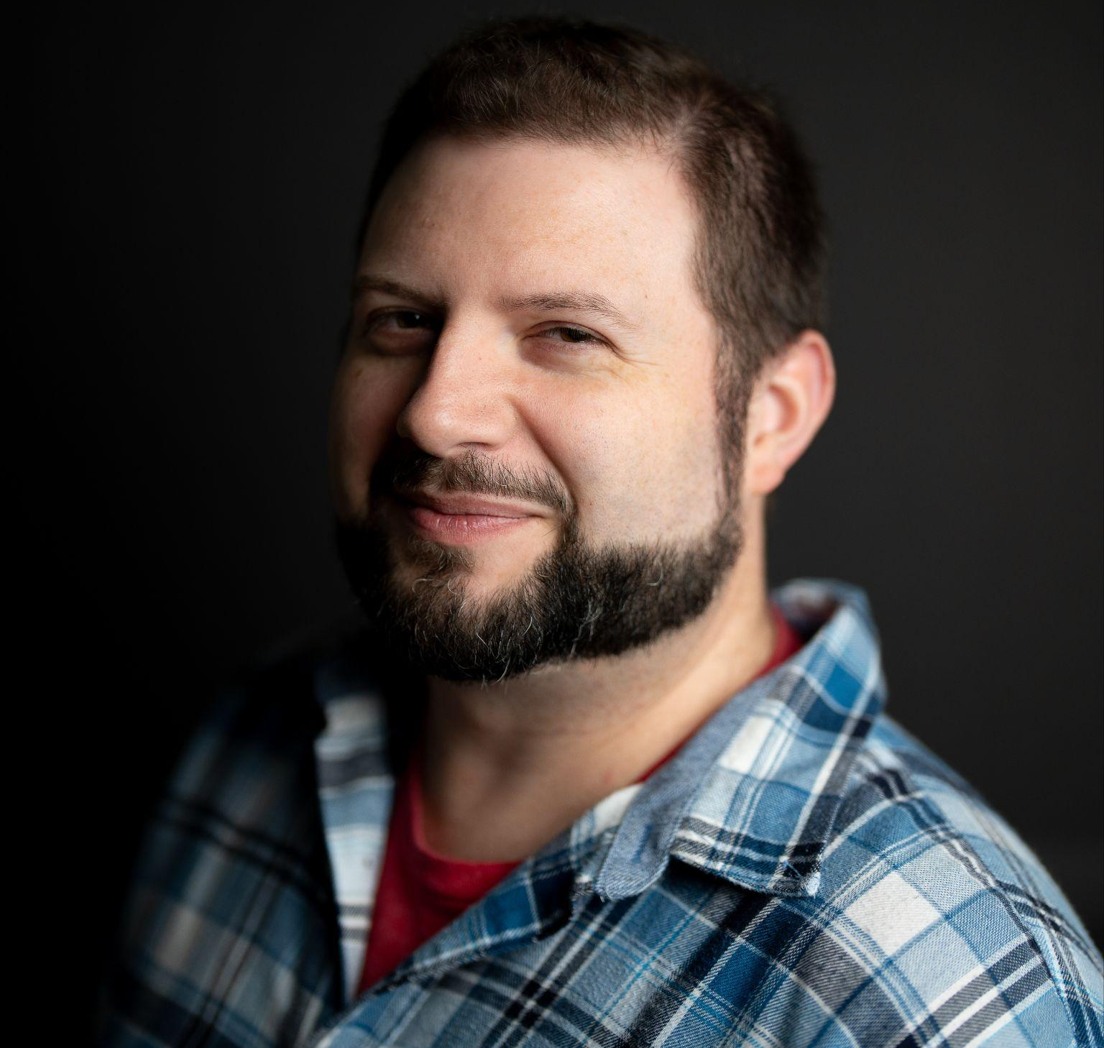  Attributes at a Glance  Writing: 16+ years  Editing: 16+ years  Project Management: 11+ years  AI Knowledge: 9+ years  Marketing: 9+ years  Social Media Management: 9+ years  Team Leadership: 8+ years  Paid Media: 8+ years  Producer: 8+ years  Influencer Management: 8+ years  Community Management: 6+ years  On-Camera Talent: 4+ years  Localization: 3+ years  Tools  Microsoft Office: Excel, PowerPoint, Teams, Word  Content Management: Opal, Sprinklr, Sprout, WordPress  Project Management: Basecamp, Jira, SharePoint, SmartSheet  Miscellaneous: Adobe Suite, Claude AI, Figma  What Makes Me Chris  Quick-witted  Problem-solving oriented  Attentive to details  Deeply empathetic  Calm under pressure  Eager to make friends  Driven to help others  Passionate about jigsaw puzzles  Unashamed Nintendo fan  Lover of dad jokes  Proud cat owner  Supporter of my family | SUMMARY  Empathetic writer, content creator, and outgoing leader. Detailed and attentive producer with experience in high-stress environments under tight deadlines. Personable and friendly. Quick to listen, quick to learn, and quick to deliver exceptional work.  KEY SKILLS  - Production and team lead in groups ranging from 5-50 people  - Copywriting, content creation, editing, and paid media  - Social media (X, Facebook, Bluesky, Instagram, LinkedIn, YouTube, Discord)  - Microsoft Office, Adobe Suite, AI, Jira, Sprout, Sprinklr, SmartSheet, AP, CMS  - Influencer negotiations and management, VIP guest handling  - Localization and video game narrative writing, plus voice direction  EXPERIENCE  Senior Writer/Influencer Manager/Producer, Caffelli  Portland, OR — August 2016 - February 2026  Oversaw copy for social media, paid media, video scripts, newsletters, blogs, websites, white pages, emails, and more. Analyzed trends and performed qualitative and quantitative research on campaigns.  Acted as a project manager to maintain social schedules, ensured properly QAed deliverables, communicated with clients, and coordinated between teams.  Studied AI to understand it at a deep level, specifically what it is, how it functions, and the best places to use or avoid using it to maximize efficiencies.  Functioned as a community manager for all client-owned social handles.  Discovered and vetted potential content creators, negotiated rates, handled communication, and ensured campaign deliverables.  Volunteer Coordinator/VIP Handler, Portland Retro Gaming Expo  Portland, OR — October 2019 - Current  Acts as a “Mega Boss” to manage volunteers, lead event setup, assist VIP guest speakers, provide conflict resolution, and address and solve problems.  Localization Writer/Editor, Nintendo of America  Redmond, WA — July 2012 - August 2015  Created, localized, and edited English text for AAA Nintendo Wii U and 3DS titles such as Animal Crossing: New Leaf, Hyrule Warriors, and Star Fox Zero. Acted as a voice director for multiple titles.  Crafted, localized, and edited English text for Nintendo Wii U e-manuals such as The Legend of Zelda: Wind Waker HD, Yoshi’s Woolly World, Hyrule Warriors, and Wii Sports Club.  Served as a project manager interacting with other departments and teams such as Marketing, Social Media, Design, Legal, Testing, Trade Shows, and Executives.  Collaborated with Spanish and French writers to discuss ideas, terms, and concepts consistent with brand legacy.  Writer/Actor/Producer, The Escapist  Portland, OR and Redmond, WA — June 2011 - April 2015  Co-created, wrote, and hosted a web show called No Right Answer, as well as a podcast called Media Sandwich, while also managing social media channels.  Head Writer/Editor, Toy-TMA.com  Eugene, OR and Portland, OR — July 2009 - April 2012  Created copy and edited daily content for a toy and pop culture WordPress-based website while managing other writers, maintaining the website, and performing SEO.  EDUCATION  Bachelor of Arts in English, The University of Oregon  Eugene, OR — January 2006 - June 2010  Executive Producer for Duck U (weekly student-run variety program)

